SISSG CONGRESS 2022

“EDIBLE OILS AND FATS: INNOVATION AND SUSTAINABILITY IN PRODUCTION AND CONTROL”
PERUGIA (IT), JUNE 15th-17th 2022

Registration Form

Name ……………………………… Address …………………………
Surname ………………………….. City ………………………………

Affiliation ………………………….. Zip code …………………………
Email ………………………………. Phone no. ……………………….

VAT no. ……………………………. Fiscal code ………………………

SISSG/EFL member Yes ◻ NO ◻

Please select one
SISSG o EFL member | 200 euro | ◻
Not SISSG or EFL member | 300 euro | ◻
Junior researchers (under 30 years old) | 100 euro | ◻
The Congress fee must be paid by bank transfer to SISSG by using the following data: BANCA INTESA SAN PAOLO 55000 - Filiale Accentrata Piazza Paolo Ferrari 10, Milano
IBAN IT 57 N030 6909 6061 0000 0119 658 BIC/SWIFT BCITITMM

Please report as reason for money transfer the following: “Congresso SISSG Perugia 2022 – Name of Delegate”

This form must be sent by e-mail to: Tesoriere.SISSG@fastwebnet.it

Please be informed that the registration process will close one week before the Congress start.
On-site registration before or during the Congress is not allowed

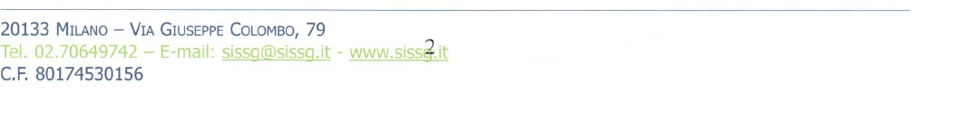
1

