Sponsorship
SISSG Congress “Edible oils and fats: Innovation and sustainabilityin production and control” – Perugia, 15-17 Giugno 2022

☐ | Platinum sponsor 4000,00 Euro | 3 free registrations  Company logo on Symposium documents (web,invitation mail invitation, Symposium posters, Symposium flyiers, Symposium scientific programme, company documents inside the symposium carpeti)  Sponsor’s logo in the “totem” inside the congress hall Sponsor’s logo in the SISSG web site . Perugia symposium 1 table in the hall outside of the congress hall, with 1 table
☐ | Golden sponsor 3000,00 Euro | 2 free registrations  Company logo on Symposium documents (web,invitation mail invitation, Symposium posters, Symposium flyiers, Symposium scientific programme, company documents inside the symposium carpet)  Sponsor’s logo in the “totem” inside the congress hall Sponsor’s logo in the SISSG web site . Perugia symposium  1 table in the hall outside of the congress hall, with 1 table
☐ | Silver sponsor 1500,00 Euro | 1 free registrations  Company logo on Symposium documents (web,invitation mail invitation, Symposium posters, Symposium flyiers, Symposium scientific programme, company documents inside the symposium carpeti)  Sponsor’s logo in the “totem” inside the congress Sponsor’s logo in the SISSG web site . Perugia symposium 1 table in the hall outside of the congress hall, with 1 table
☐ | Bronze sponsor 1000,00 Euro | Company logo on symposium brochures, logo (small dimensions) in the Symposium “totem” Sponsor’s logo in the SISSG web site . Perugia symposium  1 table in the hall outside of the congress hall, with 1 table
☐ | 1 Coffee Break o basic sponsor 500,00 Euro | Sponsor’s logo (small) in the symposium documents and on the flyer (reported as Coffee break offered by the sponsor)
☐ | Table exhibition 500,00 Euro | 1 table in the hall outside of the congress hall, with 1 table

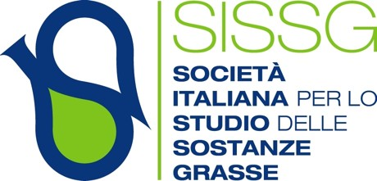

Azienda / Company …………………………………………………
………………………………………………………………………… Legal address……………………………………………………….
P.IVA /VAT Number ………………………………CF ……………………………

The amount for sponsorship would be sent by bank transfer to SISSG by using the following data:

BANCA INTESA SAN PAOLO 55000 - Filiale Accentrata IBAN IT 57 N030 6909 6061 0000
0119 658
BIC/SWIFT BCITITMM

Please report as reason for money transfer the following: “Sponsorizzazione Congresso SISSG Perugia 2022” with reference to the kind of sponsorship reported in the table.
This sponsorship form must be sent by e-mail to: Tesoriere.SISSG@fastwebnet.it

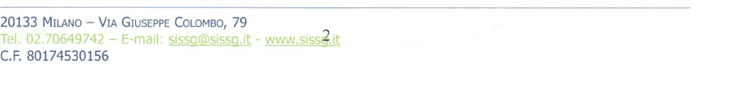
7

